APPLICATION PROCESSOR CARD

Hardware Requirement Specification
Rev-0.4

7-Apr-11

Ownership Disclaimer
This document contains proprietary and confidential material that is the sole property of Compressor Controls Corporation. The information contained herein is intended for internal use by Compressor Controls Corporation employees and is not intended for distribution outside of the company. As an unpublished work of trade secrets, the recipient shall keep this document confidential. Any re-use, copying, or distribution, either in whole or in part, of this material without the express written consent of Compressor Controls Corporation is strictly forbidden.
Copyright © 2011 by Compressor Controls Corporation. All rights reserved.

Revision History

Rev. | Date | Revised By | Description
0.1 | 24-Mar-11 | Akhilesh Jaiswal | Initial Draft
0.2 | 30-Mar-11 | Akhilesh Jaiswal | - Common section applicable all the NGP cards removed  - Block diagram updated
0.3 | 5-Apr-11 | Akhilesh Jaiswal | SD card interface requirement updated
0.4 | 7-Apr-11 | Akhilesh Jaiswal | Review comments from Vinay Nayak incorporated which include the addition of sections 2.3, 2.4, 5 and updating of section 3.11

Approvals

Approved by: Date: _______________
Approved by: Date: _______________
Approved by: Date: _______________
Approved by: Date: _______________
Approved by: Date: _______________
Approved by: Date: _______________

TABLE OF CONTENTS

1 Introduction 5
1.1 Purpose 5
1.2 Audience 5
1.3 Scope 5
1.4 Acronyms 5
1.5 References 6
2 General Description 7
2.1 System Overview 7
2.2 Product Functions 8
2.3 Acceptance Criterion 8
2.4 Dependencies 8
2.5 Block Diagram 10
3 Electrical Requirements 11
3.1 Processor 11
3.2 Main (DDR) Memory 11
3.3 Flash Memory 11
3.4 EEPROM Memory 11
3.5 SD Card Interface 11
3.6 Real Time Clock 11
3.7 IEEE 1588 12
3.8 USB (Maintenance Port) 12
3.9 10/100 Ethernet Port 12
3.10 EtherCAT Backplane Interface 12
3.11 Serial ports 12
3.12 APP-APP Communication 12
3.13 Hotswap 12
3.14 Temperature Sensors 13
3.15 External Watchdog Timer 13
3.16 Supervisory Circuit 13
3.17 PCC Card Detection 13
3.18 IES Card Detection 13
3.19 Power 13
3.20 Front Panel LEDs 13
3.21 Debug/ Diagnostic 14
3.22 Components 15
3.23 Connectors 15
3.24 ESD Protection 15
4 Mechanical Requirement 16
4.1 PCB 16
4.2 Front Panel 16
5 Deliverables 16

Introduction

Purpose
The purpose of this document is to capture the hardware requirements for APP card (Application Processor card) which is used as main processing unit on New Generation Platform (NGP) control system.

Audience
This document is meant to be used by the project team members as the basis and controlling document for the design and development of APP card.

Scope
Application Processor Card is a Freescale QorIQ processor based design which will be used as main processing unit for New Generation Platform control system. This document defines the product requirements to which hardware has to be designed and manufactured. This document also covers system level requirements applicable to APP card. This document doesn’t cover the firmware/ software related requirements.

Acronyms
Acronym | Definition
APP | Application Processor Card
COP | Common-on Processor
DDR | Dual Data Rate
DIMM | Dual in line Memory Module
ESD | Electrostatic Discharge
FTC | Field Terminal Card
I2C | Inter IC
IC | Integrated Circuit
IES | Integrated Ethernet Switch
IOP | Input Output Processor
JTAG | Joint Test Access Group
NGP | New Generation Platform
PCB | Printed Circuit Board
PCC | Power Conversion Card
RoHS | Restriction of Hazardous Substances
RTC | Real Time Clock
SPI | Serial Peripheral Interface
UART | Universal Asynchronous Receiver/ Transceiver
USB | Universal Serial Bus

References
[1] Detailed Functional Specification for NGP Hardware, Part 1, Rev-3
[2] System Study for New Generation Platform Electronics and Bring-up, Rev-1
[3] P1012 QorIQ Integrated Processor Hardware Specifications, Rev-L
[4] P1021 QorIQ Integrated Processor Reference Manual, Rev-3

General Description

System Overview
New Generation Platform (NGP) is a fully redundant, duplex, highly available, fault tolerant control system intended to handle a number of digital, analog and frequency IOs in industrial applications. Below is the system block diagram of NGP.

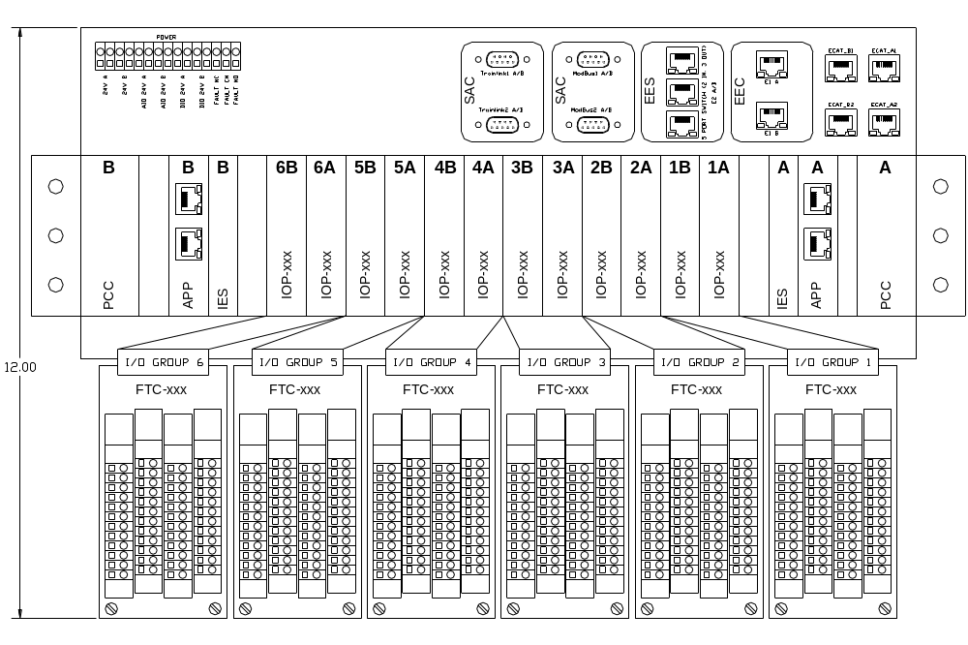
Here is the list of different electrical components in the system and their brief description.

APP
This is the main processing unit in the system. This runs the main application and does monitoring and control of the overall system. There will be a maximum of 2 such cards in an NGP system.

IOP (Digital and Analog)
These are the processors cards which handle digital, analog and frequency IOs. There will be a maximum of 12 such cards in an NGP system.

IES
This is the EtherCAT switch card used to interface between different APP and IOP modules. There will be a maximum of 2 such cards in an NGP system

PCC
This is power conversion card. The input power (redundant 24VDC) to the system first comes to this card. This card does the oring, filtering, protection and other voltage conversion. There will be a maximum of 2 such cards in an NGP system

FTC (Digital and Analog)
These are the field terminal cards where all the field loads are connected to. These are electrically interfaced to IOP cards. The number of FTC in an NGP system is same as the number of IOP card

CAC
These are the set of communication (Ethernet, RS-485) cards used for interface to the external devices

Backplane
All the above mentioned boards plug in backplane and communicate to each other over it.

Product Functions
APP is the main processing unit in the system. This is based on Freescale QorIQ processor. It runs the main application and does monitoring and control of the overall system. It implements EtherCAT master to communicate to IOPs in the system through IES board. It also implements 10/100 Ethernet and serial ports for communication to external devices.

Acceptance Criterion
Mindteck shall design, develop and deliver the hardware meeting the functionalities as detailed in section 4.0

Dependencies
    - Finalization of backplane connectors from CCC
    - PCB form factor from CCC
    - CCC shall ensure availability of
- About 10% time from an CCC’s representative for addressing queries, reviews and acceptance
- Timely inputs, reviews and approvals
- Assistance in the finalization of all the requirements specification documents
- Validation testing and approval of prototypes

Block Diagram

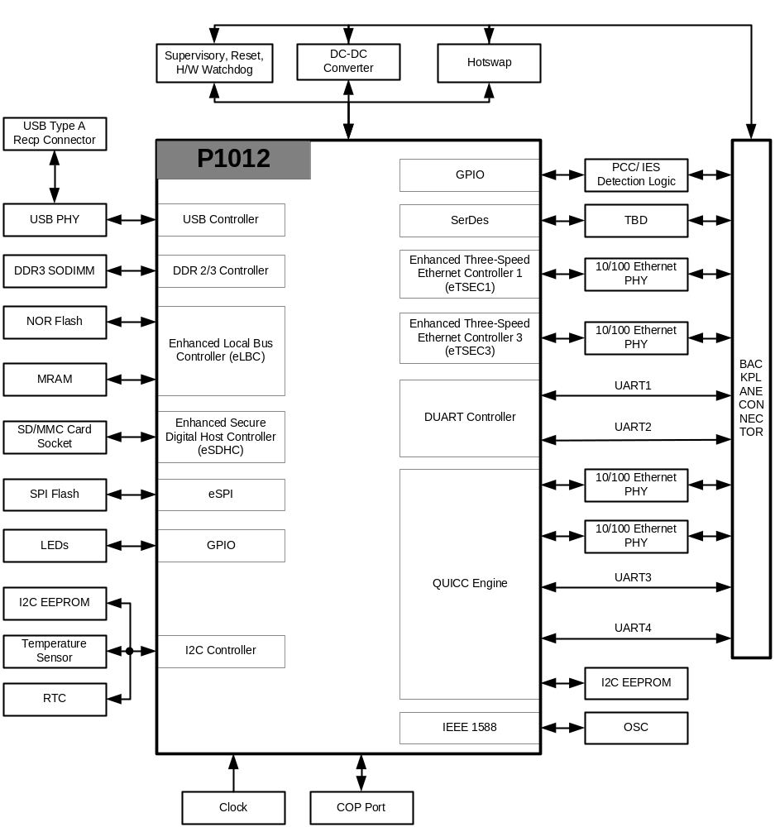

Electrical Requirements

Processor
    - Freescale QorIQ communication processor P1012 shall be used as main processing unit
    - Design shall support processor core frequencies of 533MHz, 667MHz and 800MHz

Main (DDR) Memory
    - 1GB, DDR3-667 SODIMM memory shall be implemented as main memory
    - Design shall support 2GB DDR2 memory module
    - ECC shall be supported on main memory

Flash Memory
    - 1Gbit NOR Flash shall be implemented with an option to assemble 512Mbit/ 256Mbit/ 128Mbit part.
    - 16Mbit Everspin MRAM shall be implemented with an option to assemble 4Mbit part
    - 128Mbit SPI serial Flash shall be implemented

EEPROM Memory
    - 256Kbit EEPROM shall be implemented as boot sequencer EEPROM.
    - 1Kbit EEPROM shall be implemented as board EEPROM

SD Card Interface
    - SD card interface shall be implemented
    - SD card connector shall not be placed on the front panel

Real Time Clock
    - RTC shall be implemented on the card
    - RTC shall support Seconds, Minutes, Hours, Day, Date, Month and Year
    - RTC circuit shall have battery back-up

IEEE 1588
    - IEEE 1588 shall be implemented

USB (Maintenance Port)
    - USB 2.0 host port shall be implemented as maintenance port
    - This USB 2.0 host port shall terminate to USB type A Receptacle connector on the front panel

10/100 Ethernet Port
    - Two 10/100 Ethernet MDI ports shall be implemented
    - These two Ethernet MDI ports shall be routed to the backplane connector without magnetic

EtherCAT Backplane Interface
    - Two EtherCAT ports shall be implemented
    - These two EtherCAT ports shall be routed to the backplane connector

Serial ports
    - Two Modbus RTU UART ports shall be implemented
    - Modbus RTU UART ports shall support full duplex implementation
    - Modbus RTU UART ports shall support 56kbps data transfer rate
    - Modbus RTU UART ports shall be routed to backplane connector
    - Two Trainlink UART ports shall be implemented
    - Trainlink UART ports shall support half duplex implementation
    - Trainlink UART ports shall support 315kbps data transfer rate
    - Trainlink UART ports shall be routed to backplane connector

APP-APP Communication
    - An APP-APP communication port shall be implemented
    - This port shall be routed to the backplane connector

Hotswap
    - APP card shall be hotswapable

Temperature Sensors
    - Processor temperature sensor shall be implemented.

External Watchdog Timer
    - An external watchdog timer shall be implemented to reset the processor.
    - The external watchdog timer shall have a hardware provision to disable the watchdog. This feature will be required during firmware development phase.

Supervisory Circuit
    - A supervisory circuit shall be implemented to monitor all the onboard derived voltages.
    - A power good LED, green color shall be implemented to indicate that all the on-board derived voltages are within limit.
    - The power good LED shall not be mounted on the front panel.

PCC Card Detection
    - PCC card physical insertion and removal detection logic shall be implemented.
    - PCC card physical detection logic shall identify the slot (A or B) the board is inserted to or removed from.

IES Card Detection
    - IES card physical insertion and removal detection logic shall be implemented.
    - IES card physical detection logic shall identify the slot (A or B) the board is inserted to or removed from.

Power
    - TBD

Front Panel LEDs
    - Power LED
Color | Control
Green | Hardware

    - Active LED
Color | Control
Green | Software

    - Healthy/ Ready LED
Color | Control
Green | Software

    - Alarm LED
Color | Control
Yellow | Software

    - Fault LED
Color | Control
Red | Hardware

    - Learn LED
Color | Control
Green | Software

    - CPU Activity LED
Color | Control
Green | Software

    - Communication LED???
Color | Control

Debug/ Diagnostic
    - COP/ JTAG Port
Common on-chip processor (COP)/ JTAG port shall be implemented for connection to emulator for system debugging/ programming. Position of the COP/ JTAG connector should be such that it is easily accessible when the card is installed in the system. This connector shall not be mounted on front panel
    - Diagnostic RS-232 Port
A diagnostic RS-232 port may be implemented on board using a 3-pin header depending on the feasibility. The position of the header should be such that it is easily accessible when the card is installed in the system. This header shall not be mounted on front panel.
    - User LEDs
Four user LEDs as defined below shall be implemented for debug purposes.

LED | Color | Control
User LED1 | Green | Software
User LED2 | Green | Software
User LED3 | Green | Software
User LED4 | Green | Software

    - Manual Reset Switch
A manual reset switch shall be implemented for development/ debug purpose. The position of the reset switch should be such that it is easily accessible when the card is installed in the system. This header shall not be mounted on front panel.
    - Test Points
Clip-on test points shall be implemented for key signals including all power and ground rails. The test points should be reasonably spaced to prevent test connection shorting while testing.
    - Logic Analyzer Connection
Logic analyzer connection port shall be implemented for debugging.

Components
    - All the components shall meet industrial temperature ratings
    - All other parts can be either RoHS or Non-RoHS

Connectors
    - TBD

ESD Protection
    - TBD

Mechanical Requirement

PCB
    - PCB Dimension
    - PCB Thickness

Front Panel
    - TBD

Deliverables

Mindteck shall deliver the following hardware deliverables as per the project plan for CCC review and acceptance…

- Hardware Requirements Specifications document
- Hardware Design Document
- Backplane board schematics design files
- Board Layout files & Gerber files
- Backplane board Bill of Materials
- Tested prototypes
- Test reports

